1. Go to <http://10.27.1.170:9494/default.aspx> and login your credential

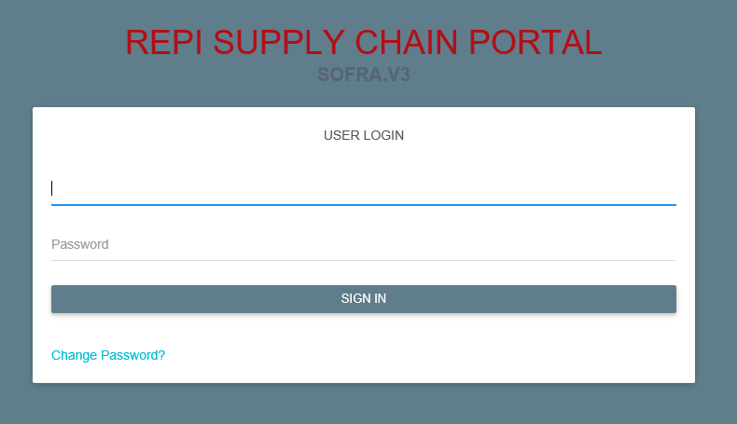

1. To create new request go to TERMINAL > Item-Unit Price Master > Transaction > Transaction Entry

Complete all the required fields before submitting the request.

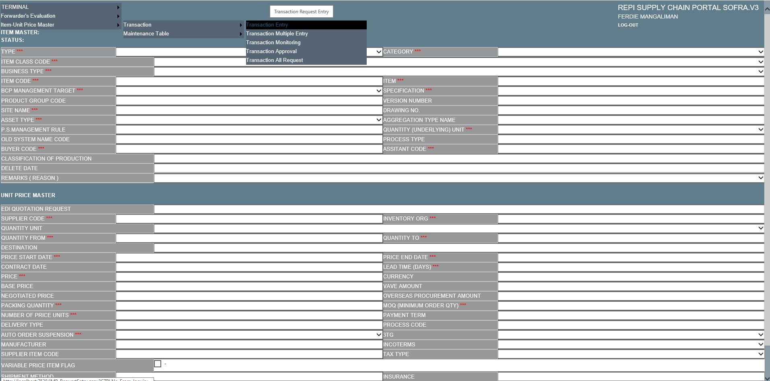

1. Click SAVE if you are done and it should be redirected to successful page if no issues.



1. To view Transaction Monitoring go to TERMINAL > TRANSACTION > Item-Unit Price Master > Transaction > Transaction Monitoring

To see details of the item, just click the DETAILS button

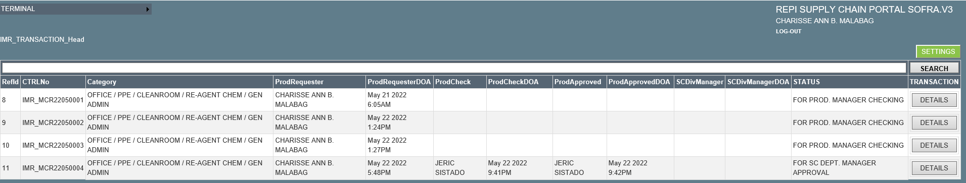

1. To View Transaction Approval go to TERMINAL > TRANSACTION > Item-Unit Price Master > Transaction > Transaction Approval

To view the details, just click the DETAILS button

Approver is able to update, approve or disapprove the request. Also available to download the excel report and attachment pdf file if there is any.

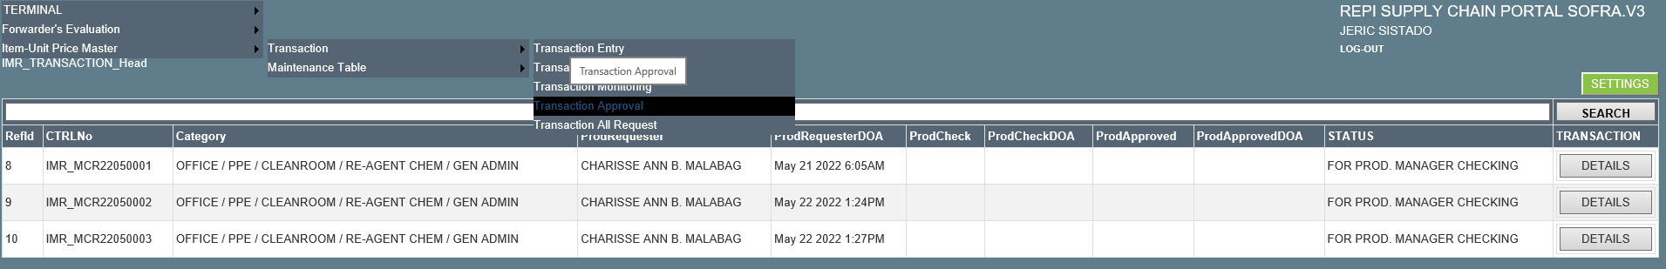

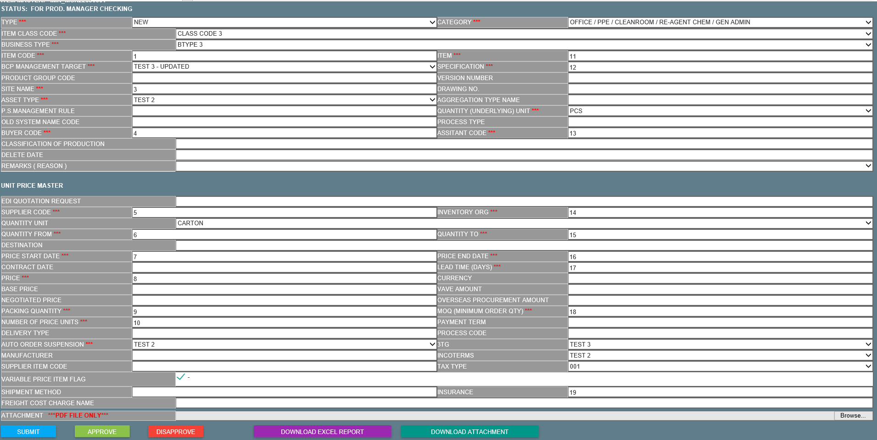

1. To view Transaction All Request go to TERMINAL > TRANSACTION > Item-Unit Price Master > Transaction > Transaction All Request

All user’s are able to view all the request.

To view the details of the request, just click the DETAILS button

